# 1. Logical Model

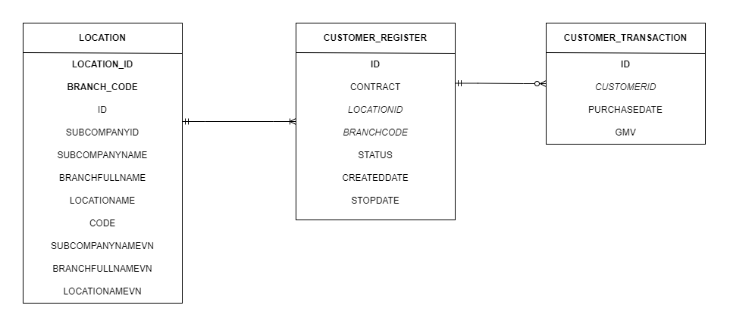

# 2. Physical Model

## 2.1. Location

|  |  |  |
| --- | --- | --- |
| **Column Name** | **Type** | **Description** |
| LocationID | int | ID of Location (Primary key) |
| BranchCode | int | Id of Branch of Location (Primary key) |
| ID | int | Surrogate key create by admin |
| SubCompanyID | int | ID of sub-company |
| SubCompanyName | varchar | Name of sub-company |
| BranchFullName | varchar | Full name of branch |
| LocationName | varchar | Full name of location |
| Code | varchar | Representative code of location |
| SubCompanyNameVN | varchar | Sub-company name in Vietnamese |
| BranchFullNameVN | varchar | Branch full name in Vietnamese |
| LocationNameVN | varchar | Location full name in Vietnamese |

## 2.2. Customer Registered

|  |  |  |
| --- | --- | --- |
| **Column Name** | **Type** | **Description** |
| ID | Int | Customer ID (primary key) |
| Contract | varchar | Contract between customer and corporation |
| LocationID | Int | ID of Location (Foreign key) |
| BranchCode | Int | ID of Branch of Location (Foreign key) |
| Status | Int | Customer status |
| CreatedDate | Datetime | Date when customer registered |
| StopDate | datetime | Date when customer stopped |

## 2.3. Customer Transaction

|  |  |  |
| --- | --- | --- |
| **Column Name** | **Type** | **Description** |
| ID | Int | Transaction ID (primary key) |
| CustomerID | Int | ID of customer (foreign key) |
| PurchasedDate | Datetime | Date when transaction performed |
| GMV | Int | Gross value of transaction |